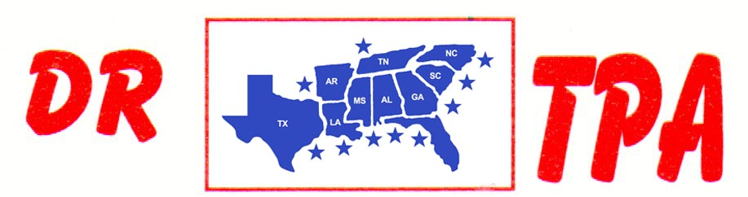

WA ARENA
SHERIDAN, AR
JANUARY 4, 2025

SHOW RESULTS - #202502

OPEN ALL DRAW RANCH SORTING - $810
1ST PLACE DOUG VOLKMAN – SKIP DAVIDSON

#3 RANCH SORTING - $630
1ST PLACE MICHAEL MOSLEY – MARK ALLEN

8 COW DRAW - $1134

GROUP A
1ST PLACE PAUL BULL
2ND PLACE SKIP DAVIDSON

GROUP B
1ST PLACE DARREN BAKER
2ND PLACE MARY HOBGOOD

#9 PENNING - $1170
1ST PLACE LAYNE PENFIELD – MARK MATHEWS – SKIP DAVIDSON

#7 PENNING - $1260
1ST PLACE GARRETT GATES – MARK MATHEWS – JASON HAYLEY

#5 PENNING (2 CAP) - $288
1ST PLACE SKIP DAVIDSON – JANEICE ALLEN – DARREN BAKER

