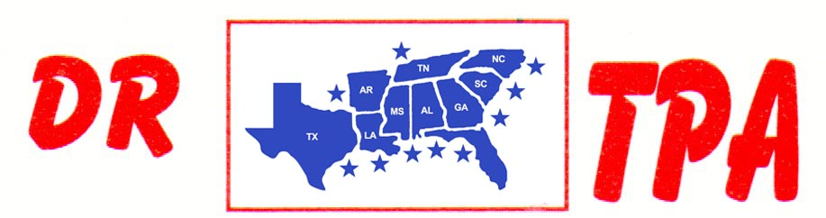

NO NAME ARENA
ALEXANDER, AR
FEBRUARY 1, 2025

SHOW RESULTS - #202505

OPEN ALL DRAW RANCH SORTING - $2240
1ST PLACE RANDY BARRETT – JAKE LINDSEY
2ND PLACE DAVID STANSBURY – COLLEEN GALLOWAY
3RD PLACE DICK TEAGUE – DAVID CARNAHAN
4TH PLACE DOUG VOLKMAN – JAKE LINDSEY
5TH PLACE PATRICIA HALL – PAUL CHILDRESS

#8 RANCH SORTING - $3324
1ST PLACE COLLEEN GALLOWAY – SKIP DAVIDSON
2ND PLACE JAKE LINDSEY – JORDAN WHITLEY
3RD PLACE JASON HALEY – LAYNE PENFIELD
4TH PLACE DICK TEAGUE – PAUL CHILDRESS
5TH PLACE WALLY HAYS – DAVID CARNAHAN

#6 RANCH SORTING - $1540
1ST PLACE CARRLIE VOLKMAN – JERRY WHITLEY
2ND PLACE JERRY WHITLEY – JANEICE ALLEN
3RD PLACE DAVID STANSBURY – JASON HALEY
4TH PLACE JANEICE ALLEN – DARREN BAKER

YOUTH SORT - $40
1ST PLACE AUBREE ENLOE (RANDY ENLOE)

