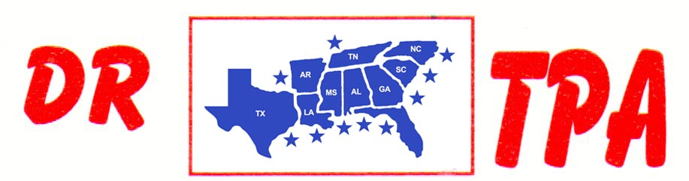

SA PRODUCTIONS, LLC
PENDLETON, SC
FEBRUARY 22-23, 2025
SHOW RESULTS - #202507

#11 MIXED PEN - $1743 ($500 ADDED MONEY)
1st PLACE RAY ROBERSON – AMANDA ROBERSON – EVIE JANE HOOPER
2ND PLACE RANDY MOORE – LAYLA SCOTT – DAY WATSON

#9 PEN - $3399 ($500 ADDED MONEY)
1ST PLACE TRENT KNIGHT – CRYSTAL PARKER – KASEY COLEMAN
2ND PLACE SCOTT KNIGHT – ABIGAIL KNIGHT – LUCAS HELMS
3RD PLACE CRYSTAL PARKER – JUAN GONZALEZ – CHET BARRETT
4TH PLACE TRENT KNIGHT – AUBREE COKER - KASEY COLEMAN

#6 PEN - $1587
1ST PLACE CHET BARRETT – EVIE JANE HOOPER – MATT KEEL
2ND PLACE MATT KEEL – EVIE JANE HOOPER – BO HOOPER

#8 SORT – $2682 ($750 ADDED MONEY)
1st PLACE COLLEEN GALLOWAY – LIZ KING
2nd PLACE RANDY MOORE – GAGE MOORE
3RD PLACE GAGE MOORE – KAI CLARK
4TH PLACE CHET BARRETT – COLLEEN GALLOWAY

#6 SHOOTOUT SORT – $7436 ($1500 ADDED MONEY)
1st PLACE RANDY MOORE – ANDIE REESE PORTH
2nd PLACE ANDIE REESE PORTH – SCOTT KNIGHT
3RD PLACE DALE BROWN – ANDIE REESE PORTH
4TH PLACE LUCAS HELMS – KAI CLARK
5TH PLACE JIMMY SPEARS – SCOTT KNIGHT
6TH PLACE RANDY MOORE – LARRY JORDAN

#5 SORT – $2110
1st PLACE EVIE JANE HOOPER – KAI CLARK
2nd PLACE KAI CLARK – BO HOOPER
3RD PLACE BO HOOPER – EVIE JANE HOOPER

#3 SORT – $2514 ($500 ADDED MONEY)
1ST PLACE JUSTIN STARNES – RANDY MOORE
2ND PLACE WALKER CARSWELL – BILL JOHNSON
3RD PLCE ANDIE REESE PORTH – JERMEY LILES
4TH PLACE RANDY MOORE – LARRY KUYPER
5TH PLACE ABIGAIN KNIGHT – SYDNEY STARNES

YOUTH SORT – $606 ($250 ADDED MONEY)
1ST PLACE NEECEY NICHOLSON – EVIE JANE HOOPER
2ND PLACE NEECEY NICHOLSON – AARON PEDRAZA

