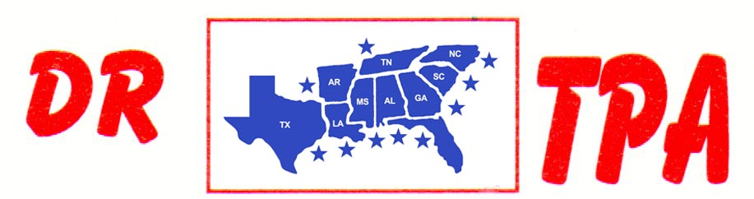

DJ COW HORSES
STARKVILLE, MS
MARCH 1-2, 2025
SHOW RESULTS - #202508

#9 PEN $3480
1st PLACE REESE STANFILL – JANEICE ALLEN – MARK ALLEN
2ND PLACE AMANDA ROBERSON – SOPHEE EVAND – DUSTIN JOHNSON
3RD PLACE DUSTIN JOHNSON – GREG REYNOLDS – SKIP DAVIDSON
4TH PLACE TANNER CHAPPELEAR – CHAD MITCHELL – KADEN DEASON

#7 PEN $6129 ($1000 ADDED MONEY)
1st PLACE ELMER WOODWARD – CHAD MORROW – JAMES DUNN
2ND PLACE CHAD MORROW – RAY ROBERSON – JAMES C. DUNN
3RD PLACE DUSTIN JOHNSON – DARREN BAKER – JAY SHACKELFORD
4TH PLACE BROOK MITCHELL – RICK DEAN – KADEN DEASON
5TH PLACE RAY ROBERSON – RICK DEAN – AMANDA ROBERSON

#5 PEN (2 CAP ON RIDER) $384
1st PLACE HUNTER SHACKELFORD – NICK HENSON – SKIP DAVIDSON

OPEN HC SORT $2484
1st PLACE TANNER KEITH – CARRIE DEAN
2ND PLACE CLAY COURSON – CARRIE DEAN
3RD PLACE DOUG VOLKMAN – SKIP DAVIDSON
4TH PLACE LAYNE PENFIELD – CHAD MITCHELL

#5 SORT $5590 ($500 ADDED MONEY)
1st PLACE LAYNE PENFIELD – SKIP DAVIDSON
2ND PLACE GREG BRIGHT – JAY SHACKELFORD
3RD PLACE PATRICK HALL – CLAY EARLS
4TH PLACE RAY ROBERSON – CINDY CRAIG
5TH PLACE DARREN BAKER – DAVID STANSBURY

#3 SORT $462
1st PLACE SIMONE STANFILL – HUNTER SHACKELFORD

8-COW DRAW – GROUP A - $1324
1ST PLACE CARRIE DEAN
2ND PLACE BROOKE MITCHELL
3RD PLACE JOHNSON DUSTIN

8-COW DRAW – GROUP B - $1323
1ST PLACE SOPHEE EVAND
2ND PLACE CHEYENNE KOESTERS
3RD PLACE CHAD MITCHELL

YOUTH PEN $249
1st PLACE SPOHEE EVANS – SOPHIA HENSON – LAYTON EARLS

YOUTH SORT $250
1st PLACE SPOHEE EVANS – TANNER CHAPPELEAR
2ND PLACE KADEN DEASON – SPOHEE EVANS

