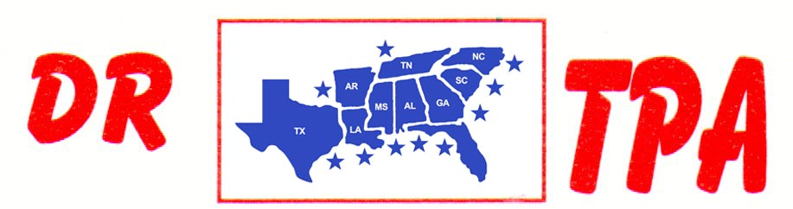

NO NAME ARENA
ALEXANDER, AR
MARCH 15, 2025
SHOW RESULTS - #202510

OPEN ALL DRAW RANCH SORTING - $2836
1ST PLACE BROOKE MITCHELL – PAUL BULL
2ND PLACE JAKE LINDSEY – BROOKE MITCHELL
3RD PLACE DAVID MCCOMAS – KADEN DEASON
4TH PLACE PAUL CHILDRESS – KADEN DEASON
5TH PLACE GARRETT GATES – WALLY HAYS

#8 RANCH SORTING - $3746
1ST PLACE THOMAS DICKSON – MICHELL CARNAHAN
2ND PLACE RANDY MBARRETT – MAYA GUSTAFSON
3RD PLACE DOUG VOLKMAN – DICK TEAGUE
4TH PLACE MISTY DICKSON – MARK LINDSEY
5TH PLACE DARREN BAKER – SKIP DAIVIDSON
6TH PLACE DICK TEAGUE – PAUL BULL

#6 RANCH SORTING - $910
1ST PLACE BROOKE MITCHELL – KADEN DEASON
2ND PLACE CHAD MITCHELL – KADEN DEASON
3RD PLACE KADEN DEASON – LAYNE PENFIELD

YOUTH SORT - $60
1ST PLACE AUBREE ENLOE – KADEN DEASON

