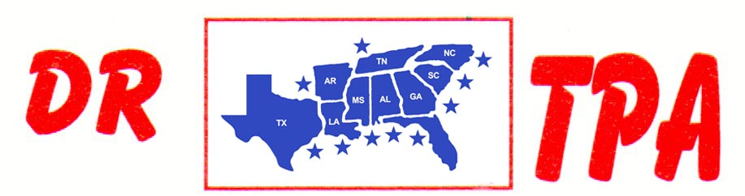

5K ARENA
BLADENBORO, NC
MAY 24-26, 2024
SHOW RESULTS - #202423

#9 MIXED PEN (w/#5 Incentive) - $894
1st PLACE IVEY KING – CRYSTAL PARKER – COTTON EAVERS
2ND PLACE IVEY KING – MOLLY EHRENCLOU – GINNY EHRENCLOU
3RD PLACE MARCI SPEARS – KASEY COLEMAN – LIZ KING

#5 INCENTIVE – $315
1ST PLACE MARCI SPEARS – KASEY COLEMAN – LIZ KING
2ND PLACE NATALIE – KASEY COLEMAN – SARAH EAVERS

#OPEN HC SORT – $416
1st PLACE SARAH EAVERS – JERRY SALTER
2ND PLACE MIKE DILLON – JERRY SALTER

#8 SORT (w/#5 Incentive) – $1712 ($500 ADDED MONEY)
1st PLACE DAVID KINK – MIKE DILLON
2ND PLACE IVEY KING – MIKE DILON
3RD PLACE CRYSTAL PARKER – LIZ KING
4TH PLACE JERRY SALTER – KASEY COLEMAN

#5 INCENTIVE– $370
1st PLACE CRYSTAL PARKER – LIZ KING
2nd PLACE KASEY COLEMAN – JERRY SALTER
3RD PLACE MANDY SINGLETON – LAYLA SCOTT
4TH PLACE MIKE DILLON – CHRISTIAN WARREN

#3 SORT – $820
1st PLACE DWAYNE CARELOCK – JIMMY SPEARS
2ND PLACE JUSTIN JOHNSON – GARY LAPIERRE
3RD PLACE JERRY SALTER – NATALIE BARKER
4TH PLACE BRIAN ABERNATHY – DWAYNE CARELOCK

YOUTH SORT – $32
1st PLACE ELAINA ELDERBAUM – ADDY WYDOCK

