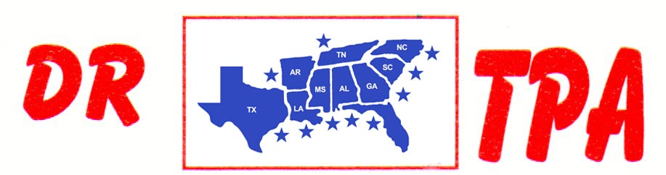

DJ COWHORSES
MCCOOL, MS
MAY 25, 2024

SHOW RESULTS - #202418

8 COW DRAW - CLASS A – $788
1st PLACE CHAD MITCHELL
2ND PLACE VAN CLAYTON
3RD PLACE LAUREN WHITE

8 COW DRAW - CLASS B – $788
1st PLACE BO WELLLS
2nd PLACE CARRIE DEAN
3RD PLACE AMANDA ROBERSON

3 MAN 2 GATE – $630
1st PLACE CHAD MORROW – CHAD MITCHELL – RAY ROBERSON

