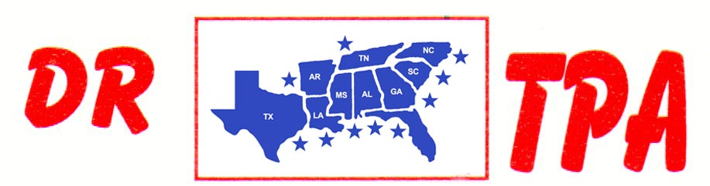

MO BETTA PRODUCTIONS
NEW IBERIA, LA
JUNE 1-2, 2024

SHOW RESULTS - #202419

8 COW DRAW - $700
1st PLACE MARK MATTHEWS 44 COWS
2ND PLACE PRESTON WEBB 39 COWS

#6 RANCH SORT – $150
1st PLACE PRESTON WEBB – MARK MATTHEWS

