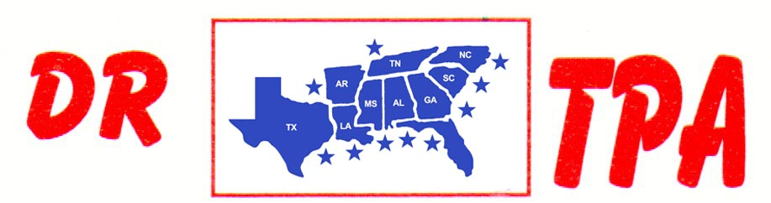

E4 FARMS
BROOKHAVEN, MS
JUNE 8, 2024

SHOW RESULTS - #202420

8 COW DRAW - CLASS A – $578
1st PLACE DAVID STANSBURY
2ND PLACE AUBREE DALE
3RD PLACE ANDY LOPINTO

8 COW DRAW - CLASS B – $578
1st PLACE JONATHAN LOPINTO
2ND PLACE DEBBIE GAUNTREAU
3RD PLACE HANNAH HALL

3 MAN 2 GATE – $630
1st PLACE JOHN CHRIS ALISON – CAROL STANSBURY – PATRICK HALL

OPEN HC PENNING - $585
1ST PLACE ANDY LOPINTO – DARRELL BUTLER – LAYTON EARLS

