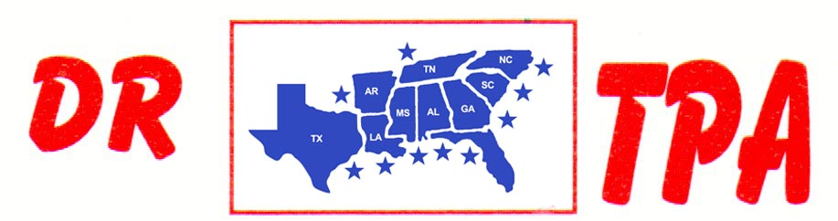

5K ARENA
BLADENBORO, NC
JULY 5-7, 2024
SHOW RESULTS - #202426

#9 MIXED PEN (w/#5 Incentive) - $819
1st PLACE FRED KRAMER – DALE TENNANT – MEGAN TENNANT
2ND PLACE FRED KRAMER – DAY WATSON – CLINT PRICE

#5 INCENTIVE – $90
1ST PLACE MITZI CONWAY – MEGGIN STEWART – FRED KRAMER

#6 SORT – $988
1st PLACE IVEY KING – DAY WATSON
2ND PLACE LARRY JORDAN – JERRY SALTER
3RD PLACE JERRY SALTER – DALE TENNANT
4TH PLACE MIKE DILLON – MEGAN TENNANT

#3 SORT – $462
1st PLACE FRED KRAMER – EARL BATEMAN
2ND PLACE BRIANNA BISHOP – JERRY SALTER

#2 – 5 COW BEGINNER SORT – $198
1st PLACE OLIVIA DOUGLASS – SAVANNAH TEASLEY
2ND PLACE SHANE SCHMELZLA – OLIVIA DOUGLASS

YOUTH SORT – $76
1st PLACE COATS KING – ADDY WYDOCK

8 COW DRAW – $224
1st PLACE IVEY KING

