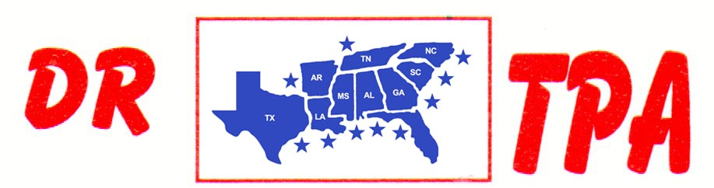

SOUTHERN RANCH SORTING
DUNNELLON, FL
JULY 19, 2024

SHOW RESULTS - #202427

8 COW DRAW - $7839
1st PLACE JJ GONZALES
2ND PLACE JOSH COCHRAN
3RD PLACE CHAD DAY
4TH PLACE SARAH FOTI
5TH PLACE PAM HARRELL
6TH PLACE JIM DUNCAN
7TH PLACE JUAN CARLOS GONZALES
8TH PLACE CLAY COURSON

OPEN HC SORT – $484
1st PLACE HANNAH DAMONE – JIMMY DUNCAN
2ND PLACE ALEJANDRO SERPONE – AMBER DUNCAN

#6 SORT - $3674
1ST PLACE SARAH FOTI – ROSS HARPER
2ND PLACE MURAY KENT – ROSS HARPER
3RD PLACE GAVIN GOSIK – SALLY SHELL
4TH PLACE MURAY KENT – CLAY COURSON
5TH PLACE PEGGY LITT – SARAH FOTI
6TH PLACE ARIC ADAMS – JAYME CONKLIN

