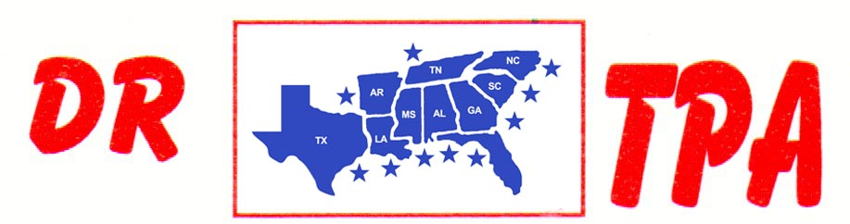

E4 FARMS
BROOKHAVEN, MS
JULY 20, 2024

SHOW RESULTS - #202425

8 COW DRAW - CLASS A – $630
1st PLACE CHAD MITCHELL
2ND PLACE AUBREE COOPER
3RD PLACE NATHAN HAYES

8 COW DRAW - CLASS B – $630
1st PLACE HENRY GIBBS
2ND PLACE JONATHAN LOPINTO
3RD PLACE HUNTER SHACKELFORD

3 MAN 2 GATE – $720
1st PLACE KADEN DEASON – LAYTON EARLS – HENRY GIBBS
2ND PLACE KADEN DEASON – CHAD MITCHELL – TANNER CHAPPELEAR

OPEN HC PENNING - $630
1ST PLACE RAY ROBERSON – LAYTON EARLS – HENRY GIBBS
2ND PLACE AMANDA ROBERSON – KATIE HAYES – LAYTON EARLS

YOUTH - $144
1ST PLACE KADEN DEASON – TANNER CHAPPELEAR

