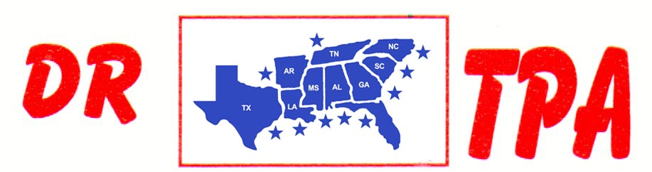

BUCKNER COW HORSES
LORENA, TX
JULY 20-21, 2024
SHOW RESULTS - #202324

OPEN HC PENNING - $1320
1st PLACE JOE FORNEY – LARRY JORDAN – RANDY SHEPPARD
2ND PLACE JOHN CECIL – LARRY JORDAN – BECKIE SHEPPARD

#12 MIXED PENNING - $1260
1st PLACE DANIE TELTOW – BRIAN BUCKNER – RONNIE MITCHELL
2ND PLACE LARRY JORDAN – DANIE TELTOW – RANDY SHEPPARD

#10 PENNING - $1440
1st PLACE MIKE ROBINSON – SONYA BUCKNER – DAVID TELTOW
2ND PLACE WAYNE VINSON – SONYA BUCKNER – BECKIE SHEPPARD

#10 PENNING - $1560
1st PLACE DAVID TELTOW – LARRY JORDAN – BRIAN BUCKNER
2ND PLACE RHONDA HARVEY – WAYNE VINSON – KENNETH ALTOM
3RD PLACE MICHAEL BAZE – LARRY JORDAN – MIKE ROBINSON

#8 PENNING - $480
1ST PLACE RONNIE MITCHELL – MICHAEL BAZE – BECKIE SHEPPARD

ALL DRAW RANCH SORTING - $960
1ST PLACE SONYA BUCKNER – MICHAEL BAZE
2ND PLACE BRIAN BUCKNER – RONNIE MITCHELL

#9 RANCH SORTING - $2760
1ST PLACE VAL TAMME – AMY BUCKLER
2ND PLACE KORI HAILE – BRIAN BUCKNER
3RD PLACE STEVE CAWTHON – HANNAH CROUCH
4TH PLACE MICHAEL BAZE – MIKE ROBINSON
5TH PLACE SCOTT HENDERSON – DAVID TELTOW

#8 MIXED RANCH SORTING - $1000
1ST PLACE AMY BUCKLER – MIKE ROBINSON
2ND PLACE SONYA BUCKNER – RHONDA HARVEY

#5 RANCH SORTING - $1080
1ST PLACE SHELBY CAWTHON – MICHAEL BAZE
2ND PLACE WAYNE VINSON – RONNIE MITCHELL
3RD PLACE RANDY SHEPPARD – RONNIE MITCHELL

#1 BEGINNER RH SORTING
1ST PLACE PAIGE KEY – BILL KEY
2ND PLACE PAIGE KEY – RANDY SHEPPARD
3RD PLACE ROBERT RISER – KENNETH ALTOM

