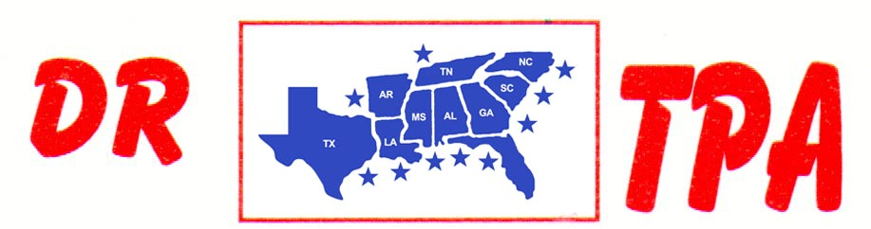

E4 FARMS
BROOKHAVEN, MS
AUGUST 3, 2024

SHOW RESULTS - #202429

3 MAN 2 GATE – $360
1st PLACE HANNAH HALL – PATRICK HALL – CALLIE OWENS

RANCH SORTING - $840
1ST PLACE TAYLOR NEWMAN – HANNAH HALL
2ND PLACE JOE FORNEY – HALLIE HORNSBY
3RD PLACE TAYLOR NEWMAN – HENRY GIBBS

