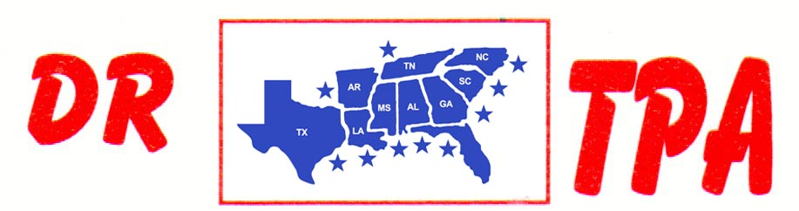

BUCKNER COW HORSES
LORENA, TX
AUGUST 304, 2024
SHOW RESULTS - #202329

OPEN HC PENNING - $1200
1st PLACE BRIAN BUCKNER – DANIE TELTOW – JOHN CECIL
2ND PLACE DANIE TELTOW – BRIAN BUCKNER – MANDIE O’NEIL

#12 MIXED PENNING - $1080
1st PLACE SHIANN BUCKNER – RHONDA HARVEY – MANDIE O’NEIL
2ND PLACE BRIAN BUCKNER – DEANNE SAMPSON – RANDY SHEPPARD

#10 PENNING - $1620
1st PLACE VAL TAMME – AMY BUCKLER – MARY MARSH
2ND PLACE RENEE PIENAAR – BRIAN BUCKNER – MANDIE O’NEIL
3RD PLACE BRIAN BUCKNER – JOHNNIE LUSK – MARY MARSH

#8 PENNING - $1080
1st PLACE SHERRI JOHNSON MCDONALD – JOHN CECIL – MARY MARSH
2ND PLACE AMY BUCKLER – RANDY SHEPPARD – MARY MARSH

ALL DRAW RANCH SORTING - $1000
1ST PLACE BRIAN BUCKNER – SHIANN BUCKNER
2ND PLACE JOHN CECIL – DEANNE SAMPSON

#9 RANCH SORTING - $2200
1ST PLACE BRIAN BUCKNER – DEANNE SAMPSON
2ND PLACE SHERRI JOHNSON MCDONALD – SHIANN BUCKNER
3RD PLACE CINDY LILES – AMY BUCKLER
4TH PLACE JOHNNIE LUSK – SHIANN BUCKER
5TH PLACE MANDIE O’NEIL – KORI HAILE

#8 MIXED RANCH SORTING - $680
1ST PLACE KORI HAILE – MIKE ROBINSON
2ND PLACE RANDY SHEPPARD – WAYNE VINSON

#5 RANCH SORTING - $960
1ST PLACE PAIGE KEY – DANIE TELTOW
2ND PLACE PAIGE KEY – SHERRI JOHNSON MCDONALD

#1 BEGINNER RH SORTING
1ST PLACE ANNABELLE BUCKNER – MIKE ROBINSON
2ND PLACE ANNABELLE BUCKNER – RHONDA HARVEY
3RD PLACE DICK BOTTOS – DAVID TELTOW

