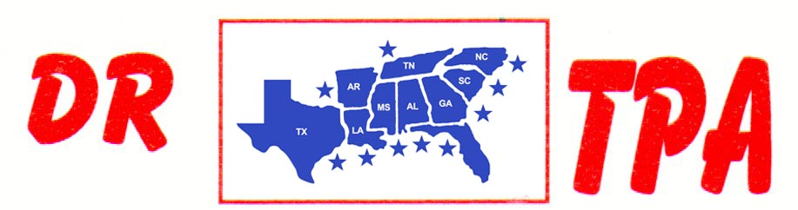

4K FARMS
YATESVILLE, GA
AUGUST 24, 2024

SHOW RESULTS - #202431

8 COW DRAW - $5648
1ST PLACE TRENT KNIGHT 44 COWS
2ND PLACE MARCUS KENT 37 COWS
3RD PLACE AMY SODREL 36 COWS
4TH PLACE DANNY SODREL 35 COWS
5TH PLACE HALEY KNIGHT 35 COWS
6TH PLACE ANGELA LAURAMORE 33 COWS
7TH PLACE LIZ KING 32 COWS

#5 RANCH SORT - $2508
1ST PLACE RENDER PIERCE – TRENT KNIGHT
2ND PLACE CARL KRAKER – HALEY KNIGHT
3RD PLACE ADAM WHEELER – HALEY KNIGHT
4TH PLACE KAI CLARK – GAGE MOORE
5TH PLACE TRENT KNIGHT – CHET BARRETT

YOUTH SORT - $500
1ST PLACE EVIE JANE HOOPER – HARPER GRACE PIERCE
2ND PLACE HARPER GRACE PIERCE – SAVANNAH TEASLEY

