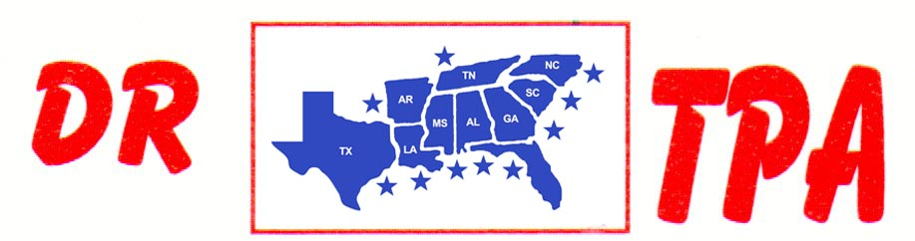

5K ARENA
BLADENBORO, NC
AUGUST 30-31, 2024
SHOW RESULTS - #202433

#13 MIXED PEN - $1092
1st PLACE FRED KRAMER – DALE TENNANT – MEGAN TENNANT
2ND PLACE LAYLA SCOTT – SHERRY STEWART – LIZ KING
3RD PLACE SHERRY STEWART – GARY LAPIERRE – DAY WATSON

#7 PEN - $1092
1st PLACE JUSTIN JOHNSON – ADDY WYDOCK – MANDY SINGLETON
2ND PLACE JUSTIN JOHNSON – IVEY KING – DAY WATSON
3RD PLACE DALE TENNANT – NICOLE STEPHFANINS – BRIAN ABERNATHY

#9 MIXED PEN - $312
1st PLACE IVEY KING – LAYLA SCOTT – SHERRY STEWART

#11 ARENA SORT – $702
1st PLACE BRIAN ABERNATHY – MANDY SINGLETON – DAVID KING
2ND PLACE MIKE DILLON – IVEY KING – DAVID KING

#9 ARENA SORT – $585
1st PLACE COATS KING – DAVID KING – HALLIE GEDDINGS

#7 ARENA SORT – $624
1st PLACE IVEY KING – NICOLE STEPHFANINS – BRIAN ABERNATHY
2ND PLACE GARY LAPIERRE – BRIAN ABERNATHY – IVEY KING

