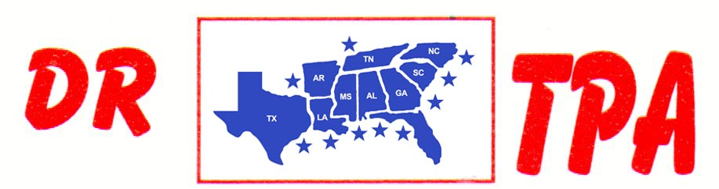

SOUTHERN RANCH SORTING
DUNNELLON, FL
AUGUST 30-31, 2024

SHOW RESULTS - #202432

8 COW DRAW - $6720
1st PLACE JOSE SANCHEZ
2ND PLACE ANNABETH GREEN
3RD PLACE BILL STANLEY
4TH PLACE SALLY SHELL
5TH PLACE HEIDI SAPP
6TH PLACE JJ GONZALES
7TH PLACE HANNAH DAMONE

#6 SORT - $3256
1ST PLACE SALLY SHELL – ANGELA LAURAMORE
2ND PLACE CLAY COURSON – CHAD DAY
3RD PLACE BECKIE LEWIS – MARCUS KENT
4TH PLACE EMMETT WHITEHURST – CHAD DAY
5TH PLACE MARCUS KENT – MARIANNE KOCHINSKI

OPEN 2 CHOW SORT
1st PLACE HANNAH DAMONE – JIMMY DUNCAN
2ND PLACE JOSE SANCHEZ – YETI GARCIA

