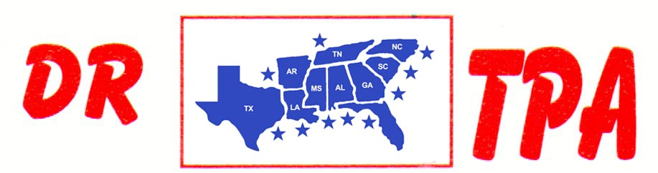

NO NAME ARENA
ALEXANDER, AR
SEPTEMBER 14, 2024

SHOW RESULTS - #202434

OPEN ALL DRAW RANCH SORTING - $1748
1ST PLACE SKIP DAVIDSON – BUCK MATHEWS
2ND PLACE GEORGE GUSTAFSON – BENJI LINDSEY
3RD PLACE CHAD MITCHELL – BENJI LINDSEY
4TH PLACE CHAD MITCHELL – KADEN DEASON
5TH PLACE DOUG VOLKMAN – KENNETH ALTOM

#8 RANCH SORTING - $1980
1ST PLACE DAVID CARNAHAN – MARK ALLEN
2ND PLACE CHAD MITCHELL – KENNETH ALTOM
3RD PLACE CHAD MITCHELL – LAYNE PENFIELD
4TH PLACE RANDY ENLOE – PAUL BULL
5TH PLACE DAVID CARNAHAN – MICHELLE CARNAHAN

#6 RANCH SORTING - $924
1ST PLACE JENNIFER HILL – SKIP DAVIDSON
2ND PLACE CHAD MITCHELL – LAYNE PENFIELD
3RD PLACE CHAD MITCHELL – KADEN DEASON

YOUTH SORTING – $100
1ST PLACE KADEN DEASON – AUBREE ENLOE

