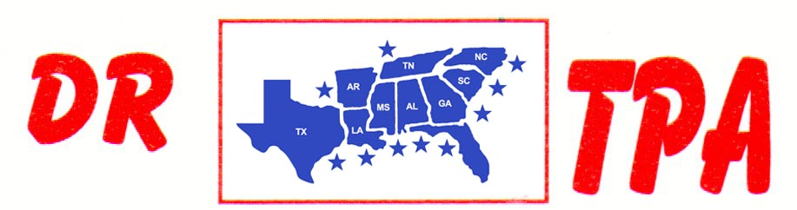

SOUTHERN RANCH SORTING
DUNNELLON, FL
SEPTEMBER 20-21, 2024

SHOW RESULTS - #202437

8 COW DRAW - $5740
1st PLACE HANNAH DAMONE 61 COWS
2ND PLACE JOSE SANCHEZ 51 COWS
3RD PLACE JOSH COCHRAN 50 COWS
4TH PLACE JIM DUNCAN 50 COWS
5TH PLACE BAILEY SHELL 49 COWS
6TH PLACE YETI CARCIA 48 COWS
7TH PLACE AMBER DUNCAN 46 COWS

#6 SORT - $3396
1ST PLACE MEL MCJANNET – TANNER KEITH
2ND PLACE BRENDA BROWN – MARCUS KENT
3RD PLACE SARAH FOTI – ROSS HARPER
4TH PLACE CLAY COURSON – CHAD DAY
5TH PLACE TANNER KEITH – CHERYL KIRTON

OPEN 2 CHOW SORT
1st PLACE SANTIAGO ESPINOZA – AMBER DUNCAN
2ND PLACE SILVIO GARCIA – EMMA DUNCAN

