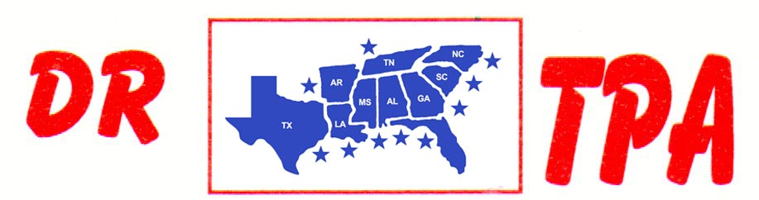

BUCKNER COW HORSES
LORENA, TX
SEPTEMBER 28-29, 2024
SHOW RESULTS - #202338

OPEN HC PENNING - $1020
1st PLACE BRIAN BUCKNER – STEVE CAWTHON – CHRIS MANGOLD
2ND PLACE VAL TAMME – JOHN CECIL – RANDY SHEPPARD

#12 MIXED PENNING - $1260
1st PLACE BRIAN BUCKNER – SHERRI MCDONALD – SONYA BUCKNER
2ND PLACE VAL TAMME – DANIE TELTOW – SHELBY CAWTHON

#10 PENNING - $1140
1st PLACE CHRIS MANGOLD – SHERRI MCDONALD – BRIAN BUCKNER
2ND PLACE CHRIS MANGOLD – VAL TAMME – AMY BUCKLER

#10 PENNING - $1560
1st PLACE RANDY SHEPPARD – ANNABELLE BUCKNER – BRIAN BUCKNER
2ND PLACE DAVID TELTOW – CHRISTINE WALTERS – JOHN CECIL
3RD PLACE CHRISTINE WALTERS – VAL TAMME – AMY BUCKLER

#8 PENNING - $840
1st PLACE TRISH TONEY – MICHELLE KLINKER – MICHAEL BAZE

ALL LEVELS RANCH SORTING - $1520
1ST PLACE VAL TAMME – JOHNNY LUSK
2ND PLACE SHERRI MCDONALD – VAL TAMME
3RD PLACE JOHNNY LUSK – CHRIS MANGOLD
4TH PLACE TRISH TONEY – RANDY SHEPPARD

#9 RANCH SORTING - $2080
1ST PLACE BRIAN BUCKNER – MANDIE O’NEIL
2ND PLACE SONYA BUCKNER – WAYNE VINSON
3RD PLACE MICHAEL BAZE – SONYA BUCKNER
4TH PLACE DAVID TELTOW – STEVE CALHOUN
5TH PLACE MANDIE O’NEIL – RHONDA HARVEY

#8 MIXED RANCH SORTING - $2000
1ST PLACE BRIAN BUCKNER – MIKE ROBINSON
2ND PLACE CINDY LILES – BILL KEY
3RD PLACE SHELBY CAWTHON – VAL TAMME
4TH PLACE PAIGE KEY – BILL KEY

#5 RANCH SORTING - $1720
1ST PLACE RONNIE MITCHELL – CHRIS MANGOLD
2ND PLACE RANDY SHEPPARD – MICHELLE KLINKER
3RD PLACE SHELBY CAWTHON – MICHAEL BAZE
4TH PLACE SHIANN BUCKNER – DOUG DUTSCHMANN

#1 BEGINNER RH SORTING
1ST PLACE PEARL MORAN – RHONDA HARVEY
2ND PLACE ANNABELLE BUCKNER – JOHN CECIL

