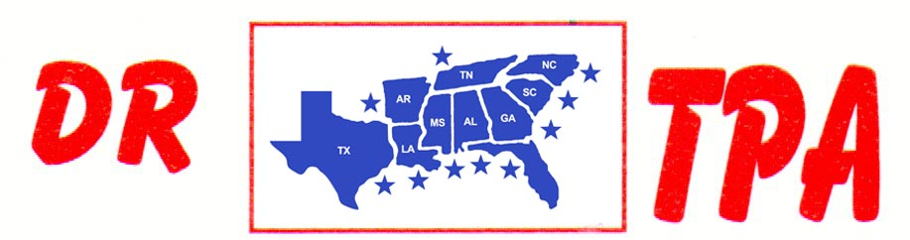

NO NAME ARENA
ALEXANDER, AR
OCTOBER 12, 2024

SHOW RESULTS - #202440

OPEN ALL DRAW RANCH SORTING - $1156
1ST PLACE DAVID STANSBURY – GARETT GATES
2ND PLACE DAVID STANSBURY – BUCK MATHEWS
3RD PLACE MARK ALLEN – LAYNE PENFIELD

#8 RANCH SORTING - $1420
1ST PLACE DOUG VOLKMAN – GARETT GATES
2ND PLACE CHRISTY HALEY – LAYNE PENFIELD
3RD PLACE DAVID CARNAHAN – LAYNE PENFIELD
4TH PLACE GARETT GATES – DAVID STANSBURY

#6 RANCH SORTING - $528
1ST PLACE LAYNE PENFIELD – DAVID CARNAHAN
2ND PLACE JASON HALEY – LAYNE PENFIELD

YOUTH SORTING – $80
1ST PLACE AUBREE ENLOE – DOUG VOLKMAN

