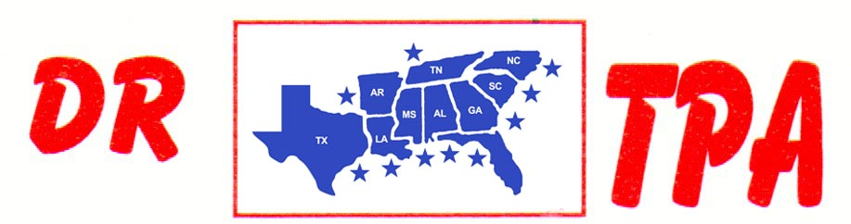

DJ COWHORSES
MCCOOL, MS
OCTOBER 12, 2024

SHOW RESULTS - #202442

8 COW DRAW - CLASS A
1st PLACE CLAY EARLS
2ND PLACE RAY ROBERSON
3RD PLACE HEATH HENDRIX

8 COW DRAW - CLASS B
1st PLACE CHAD MITCHELL
2nd PLACE LEE EARLS
3RD PLACE SOPHEE EVANS

3 MAN 2 GATE – $495
1st PLACE DUSTIN JOHNSON – KADEN DEASON – AMANDA ROBERSON

YOUTH SORT – $112
1st PLACE LAYTON EARLS – TANNER CHAPPELEAR

