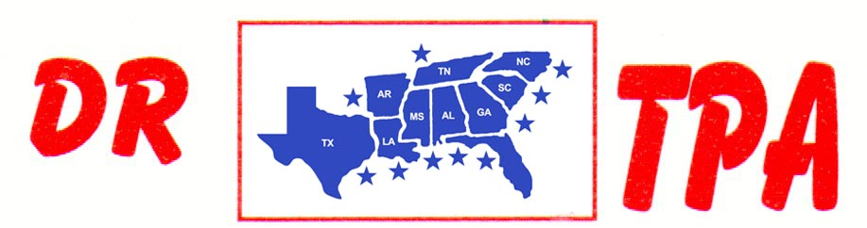

4K FARMS
YATESVILLE, GA
OCTOBER 12, 2024

SHOW RESULTS - #202439

8 COW DRAW - $3960
1ST PLACE LILLIAN HAMPTON-FORTNER 52 COWS
2ND PLACE HARPER GRACE PIERCE 43 COWS
3RD PLACE TRENT KNIGHT 40 COWS
4TH PLACE GRADY FORTNER 35 COWS
5TH PLACE LARRY JORDAN 33 COWS
6TH PLACE RANDY MOORE 30 COWS

#6 RANCH SORT - $2408
1ST PLACE HARPER GRACE PIERCE – TRENT KNIGHT
2ND PLACE AUBREE COKER – HEIDI SAPP
3RD PLACE LILLIAN HAMPTON-FORTNER
4TH PLACE ASPEN REESE – ELLA SNYDER
5TH PLACE LARRY JORDAN – KAI CLARK

SR YOUTH SORT - $626
1ST PLACE ABIGAIL KNIGHT – HARPER GRACE PIERCE
2ND PLACE ASPEN REESE – ABIGAIL KNIGHT

