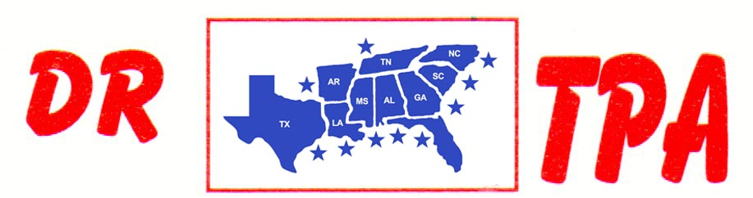

5K ARENA
BLADENBORO, NC
OCTOBER 26-27, 2024
SHOW RESULTS - #202446

#9 PEN (w/#5 INCENTIVE) - $813
1st PLACE MIKE DILLON – SHANA LIPSEY – MEGAN TENNANT
2ND PLACE CRYSTAL PARKER – COREY LILES – FRED KRAMER
3RD PLACE DAY WATSON – DALE TENNANT – CRYSTAL PARKER

#5 INCENTIVE - $315
1ST PLACE JEREMY LILES – ANNA BUTLER – IVEY POPE KING
2ND PLACE FRED KRAMER – SUZANNE BUTLER – ANNA BUTLER

#OPEN SORT – $770
1st PLACE IVEY KING POPE – SHERRY STEWART
2ND PLACE MIKE DILLON – SHERRY STEWART

#8 SORT (w/#5 INCENTIVE) – $2080 ($1000 ADDED MONEY)
1st PLACE COREY LILES – MIKE DILLON
2ND PLACE DAY WATSON – IVEY POPE KING
3RD PLACE FRED KRAMER – MIKE DILLON
4TH PLACE IVEY POPE KING – JERRY SALTER

#5 INCENTIVE - $370
1st PLACE COREY LILES – MIKE DILLON
2ND PLACE DAY WATSON – IVEY POPE KING
3RD PLACE FRED KRAMER – MIKE DILLON
4TH PLACE IVEY POPE KING – JERRY SALTER

#3 SORT – $1050
1st PLACE JENNY TAYLOR – AJ PARKER
2ND PLACE COREY LILES – BEVERLY LILES
3RD PLACE BEVERLY LILES – JERRY SALTER
4TH PLACE AJ PARKER – JEREMY LILES

YOUTH SORT - $254
1ST PLACE LUCAS HELMS – OLIVIA DOUGLASS
2ND PLACE HAIDEN BLACKMAN – LUCAS HELMS

