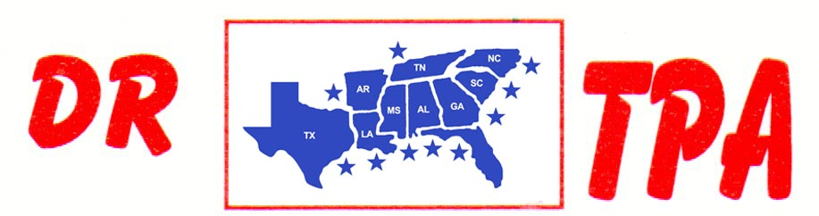

NO NAME ARENA
ALEXANDER, AR
NOVEMBER 2, 2024

SHOW RESULTS - #202443

OPEN ALL DRAW RANCH SORTING - $1680
1ST PLACE LAYNE PENFIELD – MARL ALLEN
2ND PLACE DAVID STANSBURY – DOUG VOLKMAN
3RD PLACE KADEN DEASON – DAVID CARNAHAN
4TH PLACE KENNETH ALTOM – KADEN DEASON
5TH PLACE LAYNE PENFIELD – CHAD MITCHELL

#8 RANCH SORTING - $1914
1ST PLACE SAMMY DUNCAN – DOUG VOLKMAN
2ND PLACE MICHELLE CARNAHAN – KENNETH ALTOM
3RD PLACE JOE FORNEY – RANDY ENLOE
4TH PLACE JOE FORNEY – JANEICE ALLEN
5TH PLACE CHAD MITCHELL – LAYNE PENFIELD

#6 RANCH SORTING - $924
1ST PLACE PAUL BULL – DAVID STANSBURY
2ND PLACE DAVID STANSBURY – LAYNE PENFIELD
3RD PLACE DAVID STANSBURY – CHELSEA MITCHELL

