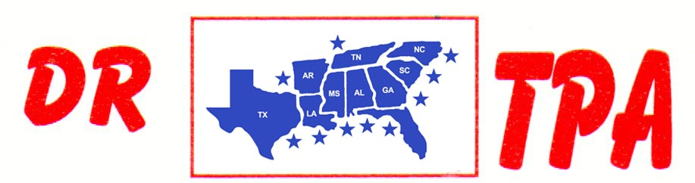

BUCKNER COW HORSES
LORENA, TX
NOVEMBER 9-10, 2024
SHOW RESULTS - #202345

OPEN HC PENNING - $1680
1st PLACE SHIANN BUCKNER – CHRISTINE WALTERS – LARRY JORDAN
2ND PLACE MIKE ROBINSON – RONNIE MITCHELL - BECKIE SHEPPARD
3RD PLACE KADEN DEASON – SHIANN BUCKNER – BRIAN BUCKNER

#12 MIXED PENNING - $4460 ($2000 ADDED MONEY)
1st PLACE MANDIE O’NEIL – BRIAN BUCKNER – MACHAEL BAZE
2ND PLACE SHIANN BUCKNER – BECKIE SHEPPARD – RONNIE MITCHELL
3RD PLACE RONNIE MITCHELL – RANDY SHEPPARD – CHAD MITCHELL
4TH PLACE KORI HAILE – RHONDA HARVEY – WAYNE VINSON

#10 PENNING - $1620
1st PLACE LARRY JORDAN – RENEE PIENAAR – DAVID TELTOW
2ND PLACE BRIAN BUCKNER – DEANNE SAMPSON – CHAD MITCHELL
3RD PLACE DAVID TELTOW – VAL TAMME – AMY BUCKLER

#10 PENNING - $4460 ($2000 ADDED MONEY)
1st PLACE CHRISTINE WALTERS – VAL TAMME – AMY BUCKLER
2ND PLACE KORI HAILE – STEVE CAWTHON – SHELBY CAWTHON
3RD PLACE KENNETH ALTOM – DAVID TELTOW – WAYNE VINSON
4TH PLACE DUSTIN WALTERS – AMY BUCKLER – SHIANN BUCKNER

#8 PENNING - $960
1st PLACE SAMANTHA LEWIS – SHIANN BUCKNER – DEANNE SAMPSON
2ND PLACE MIKE ROBINSON – LARRY JORDAN – CHAD MITCHELL

ALL LEVELS RANCH SORTING - $4320 ($2000 ADDED MONEY)
1ST PLACE BRIAN BUCKNER – SHIANN BUCKNER
2ND PLACE KORI HAILE – RANDY SHEPPARD
3RD PLACE KADEN DEASON – LARRY JORDAN
4TH PLACE BRIAN BUCKNER – RHONDA HARVEY
5TH PLACE PAIGE KEY – STEVE CAWTHON

#9 RANCH SORTING - $5040 ($2000 ADDED MONEY)
1ST PLACE BOB MCPHERSON – RANDY SHEPPARD
2ND PLACE JOHN CECIL – BRIAN BUCKNER
3RD PLACE STEVE CAWTHON – DUSTIN WALTERS
4TH PLACE CHAD MITCHELL – DAVID TELTOW
5TH PLACE DUSTIN WALTERS – KADEN DEASON

#8 MIXED RANCH SORTING - $1320
1ST PLACE BRIAN BUCKNER – KORI HAILE
2ND PLACE BRIAN BUCKNER – BECKIE SHEPPARD
3RD PLACE BOB MCPHERSON – SHIANN BUCKNER

#5 RANCH SORTING - $4840 ($2000 ADDED MONEY)
1ST PLACE KORI HAILE – AMY BUCKLER
2ND PLACE RANDY SHEPPARD KADEN DEASON
3RD PLACE STEVE CAWTHON – AMY BUCKLER
4TH PLACE BOB MCPHERSON – SHERI MCPHERSON
5TH PLACE AMY BUCKLER – TANNER CHAPPELEAR

#1 BEGINNER RH SORTING
1ST PLACE PEARL MORAN – VAL TAMME
2ND PLACE PIPER MORAN – RHONDA HARVEY
3RD PLACE ADAM GIBSON – RHONDA HARVEY

