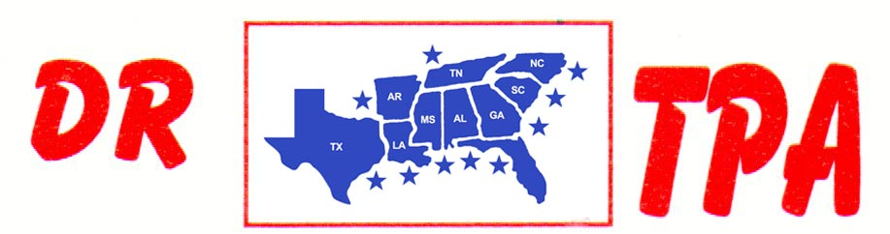

4K FARMS
YATESVILLE, GA
OCTOBER 12, 2024

SHOW RESULTS - #202439

8 COW DRAW - $3036
1ST PLACE STEVE WELCH 47 COWS
2ND PLACE JOSH COCHRAN 40 COWS
3RD PLACE LARRY JORDAN 39 COWS
4TH PLACE GAGE MOORE 38 COWS
5TH PLACE KAI CLARK 36 COWS

#6 RANCH SORT - $2014
1ST PLACE CHET BARRETT – SCOTT KNIGHT
2ND PLACE AUBREE COKER – FINN WYATT
3RD PLACE LARRY JORDAN – DANNY SODREL
4TH PLACE KAI CLARK – DANNY SODREL
5TH PLACE CAIDEN KRAKER – RANDY MOORE

#5 RANCH SORT - $1022
1ST PLACE KAI CLARK – EVIE JANE HOOPER
2ND PLACE LARRY JORDAN – GAGE MOORE
3RD PLACE RANDY MOORE – DANNY SODREL

SR YOUTH SORT - $626
1ST PLACE ABIGAIL KNIGHT – HARPER GRACE PIERCE
2ND PLACE ASPEN REESE – ABIGAIL KNIGHT

