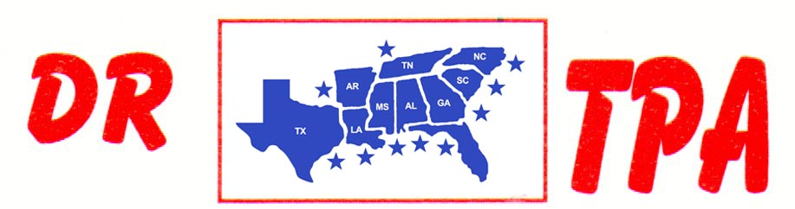

SA PRODUCTIONS, LLC
CLEMSON, SC
SEPTEMBER 14-15, 2024
SHOW RESULTS - #202435

#11 MIXED PEN - $2778 ($500 ADDED MONEY)
1st PLACE KAI CLARK – GARE MOORE – GINNY EHRENCLOU
2ND PLACE TRENT KNIGHT – AUBREE COKER – KAI CLARK
3RD PLACE MELANIE MCJANNET – DALE BROWN – TANNER KEITH
4TH PLACE GAGE MOORE – DANNY SODREL – TANNER KEITH

#9 PEN - $5541 ($500 ADDED MONEY)
1ST PLACE KEVIN REESE – BELINDA MENDENHALL – GAGE MOORE
2ND PLACE MOLLY EHRENCLOU – COLLEEN GALLOWAY – RANDY MOORE
3RD PLACE LIZ KING – DAY WATSON – DALE TENNANT
4TH PLACE CLINT PRICE – BRIAN ABERNATHY – AJ PARKER
5TH PLACE DALE BROWN – KAI CLARK – AUBREE COKER

#6 PEN - $1671 ($500 ADDED MONEY)
1ST PLACE CHET BARRETT – RANDY MOORE – LARRY JORDAN
2ND PLACE ANNA BUTLER – CHET BARRETT – JUSTIN JOHNSON

#8 SORT – $3490 ($500 ADDED MONEY)
1st PLACE RANDAL WEIDNER – GWEN ISHMAEL
2nd PLACE RANDAL WEIDNER – ELLA SNYDER
3RD PLACE TRENT KNIGHT – MOLLY EHRENCLOU
4TH PLACE SCOTT KNIGHT – AUBREE COKER
5TH PLACE KEVIN REESE – RANDY MOORE

#6 SORT – $8192 ($1000 ADDED MONEY)
1st PLACE ANDIE REESE PORTH – CASEY ROBINSON
2nd PLACE JERRY SALTER – TRENT KNIGHT
3RD PLACE DAY WATSON – GREG BRIGHT
4TH PLACE SOPHIA SELLERS – CARLY ROBINSON
5TH PLACE KASEY COLEMAN – MARCI SPEARS
6TH PLACE SCOTT KNIGHT – CHET BARRETT

#3 SORT – $5004
1ST PLACE KALEB NICHOLSON – BEN FISHER
2ND PLACE GARY LAPIERRE – SHERRY STEWART
3RD PLCE EARL BATEMAN – ANNA BUTLER
4TH PLACE SAYDEE COKER – BILL JOHNSON
5TH PLACE CHET BARRETT – RANDY MOORE
6TH PLACE GAGE MOORE – EVIE JANE HOOPER

YOUTH SORT – $
1ST PLACE

